Finding Nearest Neighbors

If we want to build recommender systems such as a movie recommender system then we need to understand the concept of finding the nearest neighbors. It is because the recommender system utilizes the concept of nearest neighbors.

The **concept of finding nearest neighbors** may be defined as the process of finding the closest point to the input point from the given dataset. The main use of this KNN)K-nearest neighbors) algorithm is to build classification systems that classify a data point on the proximity of the input data point to various classes.

import numpy as np

import matplotlib.pyplot as plt

from sklearn.neighbors import NearestNeighbors

A = np.array([[3.1, 2.3], [2.3, 4.2], [3.9, 3.5], [3.7, 6.4], [4.8, 1.9],

[8.3, 3.1], [5.2, 7.5], [4.8, 4.7], [3.5, 5.1], [4.4, 2.9],])

k = 3

test_data = [3.3, 2.9]

knn_model = NearestNeighbors(n_neighbors = k, algorithm = 'auto').fit(A)

distances, indices = knn_model.kneighbors([test_data])

print("\nK Nearest Neighbors:")

for rank, index in enumerate(indices[0][:k], start = 1):

print(str(rank) + " is", A[index])

plt.figure()

plt.title('Nearest neighbors')

#Puntos de array “A”

plt.scatter(A[:, 0], A[:, 1], marker='o', s=100, color='k')

#Puntos de array “A” con circulo a los que estan cerca de “X”

plt.scatter(A[indices][0][:][:, 0], A[indices][0][:][:, 1],

marker ='o', s =250, color ='k', facecolors='none')

#Puntos de array “test_data” se presentara como ‘X’

plt.scatter(test_data[0],test_data[1],marker ='x', s=100, color ='k')

plt.show()

Output

**K Nearest Neighbors**

1 is [ 3.1 2.3]

2 is [ 3.9 3.5]

3 is [ 4.4 2.9]

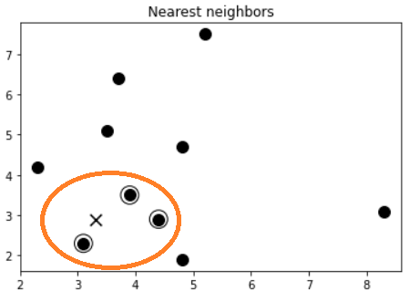

Intrepretacion: nos presenta 3 puntos del array “A” que estan mas cerca del punto “x” que tiene los puntos de “test_data”